

**PGDip: E-Skills Development with Immersive Technology**

**VRA 701 Assignment Part A & Part B**

**Survey Report: *Healthcare department***

**By**

**Lahai Rois Iradukunda (3875144)**

# 

Contents

0. Summary 3

1.0 Background/ Introduction 3

2.0 Review of Related Articles 4

3.0 Conclusion and Potential Future Recommendations 6

# Summary

All of us depend on the healthcare system, in the innovation and new technology that is evolving around, the healthcare doesn’t have to be left behind. Immersive technology is being used in different fields of life, in this surveys I searched for the involvement of healthcare system in this extended reality involvement world we are entering in, the research which have been done, or the steps that are being undertaken in order to not leave behind the healthcare system. This report is necessary because it shows the extent in which the industry is moving on, different interventions took place as well as where is the gap, where the future researchers will have to focus. Also the ideas of how the people are finding the use of Immersive technology and how they think it will affect their living style.

**1.0 Background/ Introduction**

Healthcare system is one of the complex systems in the world and need to be more attentive when introducing new invention. Currently there are more trials of the use of immersive technology in healthcare system, even though it is not more popular yet, most of the current trials of the uses of immersive technology in healthcare mostly are through education system, where they are comparing the uses of the traditional methods and the effects of using immersive technology in learning. That’s not only, also there was some trials in the surgery where the surgeons engage in the application which shows a type of surgery that has to be performed and in game ways may learn how to do it before performing to the real patients, also some are being tried for the treatment of some mental disorder, as well as blocking the pain.

Mostly in this survey am going to use the education part because is one of the fields that have been analyzed and more research have been done on that , even though in most schools they focus on theory learning and students don’t get enough time in skills lab , and some materials like mannequin in skills lab most of them can’t respond , in reality it doesn’t expose the students to the real life situation and sometimes where we find low and high functioning patient simulators often is one and all students can’t have the access at the same time. Practice without theory is blind, theory without practice is sterile” (Karl Marx, 1975, p. 182). The immersive technology is the solution that is being used in order to fix this issue, some universities have started using this system in order to train the nurses as well as the Doctors, this gives them time to get used to the medical environment as well they know what to expect the time they will be on field and start their practice.

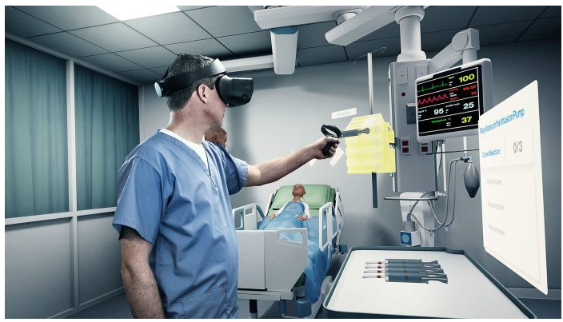

**Image 1: healthcare provider using immersive skills for self-directed learning**

# 2.0 Review of Related Articles

Nicola et al (2022) developed an application to assist the medical students that have been prevented to attend physical laboratories as well as physical classes due to covid-19. The waterfall project management system was used where one phase have been dependent on the previous one. This application gave the medical students to attend different laboratories using 3D virtual environment by using just desktop application, in those different laboratories they can learn and do different learning skills. Unity editor together with unity asset store was used to develop the app while C# was the language used for implementation and functionality.

Gilardi et al (2022) on the other hand they developed a virtual reality application for nursing students to develop their communication skills, risk assessment , holistic assessment and person centered clinical decision making skills. A SCRUM agile development process was followed by the company for the software implementation where there has been collaboration between the faculty experts, students and developers. Giraldi et (2021) design and development process has shown to be an effective model mostly because it is rooted in participatory design. The application was developed in unity engine targeting Meta quest 2 devices using the Xr interaction toolkit and designed to be played seated in one position.

Hara et al (2021) they designed and evaluated a 3D serious game for communication learning in nursing education, as a communication is a primary steps in health care , the student nurse had to be prepared in order to teach them what they should practice when dealing with a patient as well as with the family of the patient. In this game for experiencing full immersion in 3D , players had to use the VR glasses which was attached to the notepad.it was designed using Unity 2019.3.6 games engine , visual studio and blender. To automate the serious game in the future the artificial intelligence database was induced to store the players speeches.

**Table 1: *summary of the articles used.***

|  |  |  |  |  |  |
| --- | --- | --- | --- | --- | --- |
| **Reference** | **Research Focus** | **Methods Used** | **Technology used (AR/VR/MR)** | **Findings/**  **Conclusion** | **Future work** |
| Nicola (2022) | overview  of the students’ experience in developing a complex 3D application for medical  students. | Waterfall approach | VR | **Using a step or task-based methodology was efficient from the standpoint of delivering**  **a functional application.** | **we intend to test the application with medical students using new test**  **methods by automatically identifying the user activity by means of a software service:**  **Unity Analytics.** |
| Giraldi (2022) | **facilitating simulated practice and developing students risk assessment and decision-making skills.** | **SCRUM agile process** | VR | **Communication skills development was achieved.** | **consider potential research into the physical learning environment in which VR applications are used** |
| Hara (2021) | **Develop the ability to use verbal and non verbal communication with the virtual patients applying clinical reasoning and decision making.**  **B. recognize conflict and handle it in a patient centered care way.** | **Heuristic evaluation** | VR and AI | **the development of a serious game in 3D VR about**  **communication for the practice of the skill in a safe environment before**  **having the opportunity to go to real practice, offering a new teaching**  **strategy for nursing students;** | **There is a need for further investigations based on the application of**  **Comunica-Enf to assess emotions and approach the learning acquired** |

# 3.0 Conclusion and Potential Future Recommendations

Immersive technology in healthcare system is playing major roles currently , when you check on the feedback of the individuals who were exposed to it, but there are still more challenges regarding the uses of it, there is high cost when it comes to materials needed in order to uses it, and as usual the health department needs more attention where a certain innovation may not be implemented or tested to a patient due to the ethical considerations. This technology as seen is still more focusing on the education , training the healthcare workers, there supposed to develop more and some may be used in treatment options , as some few conducted studies regarding the reduction of pain during surgery , as well as it have been tried in some mental health disorder.

As an African I think we are limited to this immersive technology, there is no much studies which have been done , for future researchers would implement the immersive technology in healthcare students in Africa, and evaluate the perception.

**References**

Gilardi, M., Honnan, S., Sheerman, L., Cund, A., & Rae, S. (Accepted/In press). Nursing XR – A VR application to teach decision making to student nurses. Paper presented at European Conference on Game Based Learning

2022 , Lisbon, Portugal.

Hara, C. Y. N., Goes, F. D. S. N., Camargo, R. A. A., Fonseca, L. M. M., & Aredes, N. D. A. (2021). Design and evaluation of a 3D serious game for communication learning in nursing education. Nurse education today, 100, 104846.

Nicola, S., & Stoicu-Tivadar, L. (2022). Sharing the IT Educational Experience of Developing 3D Applications for Medical Students Training. Informatics and Technology in Clinical Care and Public Health, 289, 204.

**Part B: App Review**

The application names is 3D bones and organs (anatomy)

*It is an android app and can be found on android version of 4.4 and upward*

This application is well arranged when it comes to home pages , it is easily to choose which part of the body you want to learn also it contains more description of the organs and the bones.

*The target audience will be the students who are learning the human biology , as well as those in medical fields, it is not even limited to the lecturers and teachers who want to do some research even those people who are curious about the human body.*

*This app is serving the medical field especially on education sides of the medical fields.*

*Augmented reality is the extended reality technology that is being used by this application.*

*It only uses 3d touched interfaces.*

*It supports more than 3 languages, English, French, German and Spanish; this gives the choice, where you can use the language that you are more comfortable with. It has also minimized advertisement and it doesn’t affect the learning process, as well is a free app.*

*Mostly anatomy should go along with physiology, where if you need to know the functions of a certain organ you may get it without switching out the app, and also this app doesn’t provide different background display where you may changes the color, especially for the people who like to learn or use a certain color.*

Yes, I would recommend this app for a students who want to have a guide on how to study human anatomy the structures and their description , as this may assist you to prepare your assignments as there is a quiz option where you test yourself on knowledge you have on a certain topic.

Some of the challenges that may be faced by an XR app designer include the social unacceptancy of a certain graphics, as there is a simulation of certain things and there is a use of avatars instead of human, so this may not be appealing to some people as they may feel like they are being mentally manipulated. this goes with the lack of updated hardware as they are very expensive on the market , and so your target market may not get access on your product.

As the XR app are not that much popular it is still new innovation , and it requires the use of certain devices in order to access it there is no visible income that are being generated and the marketing is very low. And as there still more studies going around there may be some coding errors on the project you spent enough time on and at the end it malfunction.